Template 2 – Comparison Panels Procedure
Getting Started: Implementing a Traffic Sign
Retroreflectivity Maintenance Program

Ohio LTAP – April 2011

Notes & Updates – October 2013
Thank you for visiting Ohio LTAP’s Implementation Guide webpage to review resources relating to traffic sign retroreflectivity. Included with the Guide for consideration are examples of written program templates that agencies may voluntarily choose to use, or adapt, for the purpose of implementing a traffic sign retroreflectivity maintenance program.

The original sample templates from April 2011 were based on Assessment methods from the Ohio Manual of Uniform Traffic Control Devices (OMUTCD), and FHWA’s sign retroreflectivity resources. As agencies upgrade their signs and establish their long-term plans for complying with the retroreflectivity requirements, some might choose to use Management methods, or a combination of Assessment and Management methods, for maintaining sign retroreflectivity as described in the OMUTCD. Agencies may wish to revise or re-establish their written programs accordingly.

This Word document includes several updates to the attached sample template from 2011, which are highlighted in blue font. Other published examples of retroreflectivity maintenance program templates/documents might also now be available online from other sources. Please feel free to contact the Ohio LTAP Center if you have any questions.

[ Blank Page ]
Template 2 – Comparison Panels Procedure
Visual Nighttime Inspection Method
Traffic Sign Retroreflectivity Maintenance Program

April 2011 – Attached for consideration is a template that may be used, or adapted, for the purpose of implementing a traffic sign retroreflectivity maintenance program. The Ohio Manual of Uniform Traffic Control Devices (OMUTCD) sets forth the requirements for maintaining traffic sign retroreflectivity, and describes several assessment and management methods that may be used. The attached Template 2 is based on use of the Visual Nighttime Inspection Method – Comparison Panels Procedure. Visual nighttime inspections are conducted by a trained inspector.

Comparison Panels Procedure – Comparison panels are used to assess signs that have marginal retroreflectivity. The comparison panels are fabricated at retroreflectivity levels at or above the minimum levels. When the visual [nighttime] inspection identifies the retroreflectivity of a sign as marginal, a comparison panel is attached to the sign and the sign/panel combination is viewed and compared by the inspector. (“Maintaining Traffic Sign Retroreflectivity” – FHWA-SA-07-020)

As of April 2011, there are no known sources for purchasing comparison panels for this purpose. However, if your agency has access to a retroreflectometer, you can create your own using signs from the field or signs that have already been taken out of service. It may be possible to borrow a retroreflectometer from your County Engineer’s Office or another local agency in the area. Note: Comparison panels need to be properly stored, maintained, and checked with a retroreflectometer at periodic intervals to ensure that they have appropriate retroreflectivity levels. Please refer to the Federal Highway Administration (FHWA) resources listed in Appendix C of this template for detailed information and guidelines for properly using the Comparison Panels Procedure. [ October 2013 update – comparison panels are now commercially available. ]

Ohio LTAP has prepared two other program templates that may be considered. If use of comparison panels is not feasible for your agency at this time, consider using Template 3 (Consistent Parameters Procedure), instead of Template 2. The procedure described in Template 3 does not require comparison panels. Alternately, use of other methods may be considered per the OMUTCD.

Disclaimer Statement
The attached template for implementing a traffic sign retroreflectivity maintenance program was prepared by the Ohio Department of Transportation’s Local Technical Assistance Program (LTAP), as a resource that Ohio local agencies may voluntarily choose to use. Please note that your agency is not required to use any of the templates developed by Ohio LTAP. The responsibility for complying with the OMUTCD traffic sign retroreflectivity requirements rests with the public agency or the official having jurisdiction. Ohio LTAP/ODOT makes no representations, express or implied, as to whether or not this proposed template is applicable for a given agency, and assumes no liability for use of this resource package by any agency or individual. The user assumes full responsibility for their use of these resource materials (or portions thereof), and any of the information they contain.

Instructions for Using Template 2 – Comparison Panels Procedure

- Attached are two versions of this template:
  - A ‘guide’ version (including Appendices).
  - A ‘fill-in-the-blanks’ version – please see additional comments at the end of this page.*

- Review the guide version, which includes suggested information in brackets for the decision items that your agency will need to decide and fill in. For example: “Documentation from each inspection process will be kept for a period of at least ___[two; three; or other]___ years.” It is up to your agency to decide how many years the inspection documentation will be kept.

- Access the electronic copy (Microsoft Word version) of the template, which is available online:
http://www.dot.state.oh.us/Divisions/Planning/LocalPrograms/LTAP/Pages/ImplementingaTrafficSignRetroreflectivityMaintenanceProgram.aspx

- In the electronic copy of the template, make decisions and type in the data that is appropriate for your agency, for the decision items as described in step #2 above.

- The electronic version of the template can be further revised, reworded, updated, or modified based on your agency’s needs.

- Be sure to also review the Appendices, and attach any other forms, maps, documents, etc. that your agency chooses to include.

- The finalized Traffic Sign Retroreflectivity Maintenance Program document for your agency can be printed out as a hardcopy.

- It is recommended to formally adopt the program document for implementation by your agency. Please refer to the “Authorizing Signatures” section of the template. Some agencies may also have other processes/procedures that they typically use to formally adopt a program.

- The signed final document should be kept on file, with copies made and distributed as needed to the persons involved in this program. Please also note the recommended “Annual Program Review and Renewal” section of the template.

* If your agency is not able to access the electronic version of this template (per step #3 above), you may consider using the ‘fill-in-the-blanks’ paper version. The main challenge with using the ‘fill-in-the-blanks’ version is that it is more difficult to customize the document to suit your agency’s needs.

If you have any questions, please feel free to contact Ohio LTAP at (614) 387-7358 or (877) 800-0031.

If you decide to use one of the program templates in any manner, it is recommended that you review the document carefully with your County Engineer, insurance provider, or legal counsel prior to formally adopting your agency’s sign retroreflectivity maintenance program.

Traffic Sign Retroreflectivity Maintenance Program for ____________ Township (in ____________ County, Ohio) – Calendar Year ____

1. Introduction
“Retroreflectivity” refers to the property of a traffic sign to reflect light back to the driver. Retroreflective traffic signs are used to increase sign visibility at night. Maintaining sign retroreflectivity is important to promote nighttime traffic safety.

In January 2008, the Federal Highway Administration (FHWA) enacted new requirements for maintaining minimum levels of retroreflectivity for traffic signs. These requirements were established through the national Manual on Uniform Traffic Control Devices (MUTCD), and apply to all agencies that maintain roadways open to public travel. The MUTCD implementation resulted from a final rule published in the Federal Register on December 21, 2007.

The Ohio Manual of Uniform Traffic Control Devices (OMUTCD) is required to be in substantial conformance with the national MUTCD. The requirements for maintaining retroreflectivity of traffic signs in Ohio are set forth in Section 2A.08 of the OMUTCD.

The responsibility for the design, placement, operation, maintenance, and uniformity of traffic control devices rests with the public agency or the official having jurisdiction. Per Section 4511.11 of the Ohio Revised Code, local authorities shall place and maintain traffic control devices in accordance with the OMUTCD.

1.1 Implementation Requirements
The Federal Highway Administration published the following information on May 14, 2012. Source: Final Rule, Federal Register Vol. 77, No. 93.
Specific Provision: Implementation and continued use of an assessment or management method that is designed to maintain regulatory and warning sign retroreflectivity at or above the established minimum levels. Compliance Date: June 13, 2014.
Additional Comments:
Types of signs other than regulatory or warning are to be added to an agency’s management or assessment method as resources allow.
Even without specific FHWA compliance dates for replacement of signs, agencies will still need to replace any sign they identify as not meeting the established minimum retroreflectivity levels.

1.2 References
References and resources for this work include, but are not limited to:
Ohio Manual of Uniform Traffic Control Devices (OMUTCD) – current version –
http://www.dot.state.oh.us/omutcd
Section 2A.07 – Retroreflectivity and Illumination
Section 2A.08 – Maintaining Minimum Retroreflectivity
Section 2A.22 – Maintenance

Page 1
Additional parts/sections of the OMUTCD should be referred to as needed with regard to traffic sign management and maintenance functions.
Ohio Revised Code – Sections 4511.09 and 4511.11
Federal Highway Administration (FHWA) – Sign Retroreflectivity Resources
Nighttime Visibility Webpage – http://safety.fhwa.dot.gov/roadway_dept/night_visib/
Guide – http://safety.fhwa.dot.gov/roadway_dept/night_visib/sign_retro_4page.pdf

2. Policy Statement
____________________ Township will use the plan, method(s) and procedure(s) described herein to evaluate and maintain retroreflectivity of traffic signs under its jurisdiction, in accordance with the most current version of the Ohio Manual of Uniform Traffic Control Devices.

3. Implementation Plan
The anticipated steps in this plan for calendar year ____ are as follows.
- Create a traffic sign inventory for the Township (see section 4 of this document), and identify any sign problems/deficiencies that require corrective action.
- Use the selected method and procedure (see section 5) to evaluate the retroreflectivity of the Township’s traffic signs.
- Identify signs that do not meet the OMUTCD retroreflectivity requirements.
- Prioritize and schedule replacement of signs that do not meet the OMUTCD retroreflectivity requirements.

In light of the June 13, 2014 compliance date (see section 1.1), the Township hereby resolves to proceed with the implementation plan by ____________________ , or earlier if possible.

Based on experience gained as this program is implemented, the Township may review and modify its approach to this work as needed in order to:
- comply with the traffic sign retroreflectivity requirements per the OMUTCD; and
- provide for the safety of sign inspection/maintenance personnel, motorists, and other road users.
Any significant changes made to the plan, method(s) or procedure(s) will be documented.

4. Traffic Sign Inventory
Daytime inspections will be conducted to identify and document all traffic signs under the Township’s jurisdiction. At a minimum, the documentation from these inspections will include the sign type, location, and condition (see Appendix A). The inspections will also identify:
- Any damaged, deteriorated, or obscured signs, or other sign problems, that require immediate corrective action in the interest of traffic safety.
- Any signs or sign installations that do not meet the standards and requirements set forth in the OMUTCD.
The Township will take appropriate and reasonable steps to correct any sign problems/deficiencies identified.

Page 2
The data collected during the inspections will be used to create an inventory of the Township’s traffic signs. At the Township’s discretion, the sign inspection sheets may be organized in a notebook or filing system; or, data from the inspection sheets may be transferred to a separate spreadsheet or computer database. The Township will evaluate the available options and methods for long-term maintenance and updating of its sign inventory.

The Township has been divided into ___[two; or other]___ Zones for conducting traffic sign inspections (see Appendix B). The inventory process and inspection documentation will correspond to the roads and traffic signs the Township is responsible for within each Zone. The sign inventory should be completed for Zone 1 by __________________ , and for Zone 2 by __________________.

5. Method for Maintaining Traffic Sign Retroreflectivity
The OMUTCD describes several assessment and management methods that may be used to maintain traffic sign retroreflectivity. For calendar year ____, the Township will use the Visual Nighttime Inspection Method – Comparison Panels Procedure to evaluate the retroreflectivity of traffic signs on its roads. The OMUTCD describes Visual Nighttime Inspection as follows:
“The retroreflectivity of an existing sign is assessed by a trained sign inspector conducting a visual inspection from a moving vehicle during nighttime conditions. Signs that are visually identified by the inspector to have retroreflectivity below the minimum levels should be replaced.”

Comparison Panels Procedure – Comparison panels are used to assess signs that have marginal retroreflectivity. The comparison panels are fabricated at retroreflectivity levels at or above the minimum levels. When the visual [nighttime] inspection identifies the retroreflectivity of a sign as marginal, a comparison panel is attached to the sign and the sign/panel combination is viewed and compared by the inspector. (“Maintaining Traffic Sign Retroreflectivity” – FHWA-SA-07-020)

5.1 Procedure
The Federal Highway Administration has published several resources that include recommendations and instructions for proper use of the Comparison Panels Procedure to conduct visual nighttime inspections (see Appendix C). The Township will review these resources and adopt appropriate inspection practices for properly using the Comparison Panels Procedure to comply with the OMUTCD retroreflectivity standards. The procedure steps and requirements will be listed and attached to this document.

5.2 Inspector(s)
The Township hereby designates the following person(s) to serve as retroreflectivity inspector(s):

____________[ Name ]____________ ____________[ Name ]____________

The Township has determined that the designated person(s) are able to competently serve as inspector(s) for evaluating traffic sign retroreflectivity. The Township will review applicable FHWA guidelines and resources with regard to inspector training, and will determine the type(s) or extent of training their inspector(s) will need in order to perform this function in accordance with the OMUTCD requirements.

Page 3
5.3 Schedule and Documentation
The Township will begin its use of the Visual Nighttime Inspection Method – Comparison Panels Procedure to evaluate traffic sign retroreflectivity no later than __________________. The traffic sign retroreflectivity inspections should be completed for Zone 1 by __________________ , and for Zone 2 by __________________ .

The retroreflectivity inspection records will be kept in a notebook or filing system that will be accessible to the Township Trustees. Documentation from each inspection process will be kept for a period of at least ___[two; three; or other]___ years.

Looking ahead, the Township plans to conduct sign retroreflectivity assessments with a frequency of ____[ once per year; or other ]____. Future renewals or revisions of this program document will describe the timeframe or frequency for conducting retroreflectivity assessments.

6. Additional Responsibilities for Traffic Sign Management and Maintenance
Retroreflectivity is just one of several factors associated with proper functioning of traffic signs. The Township continues to be responsible for the overall management and regular maintenance of signs under its jurisdiction, in the interest of traffic safety.

The following text is included in OMUTCD Section 2A.22 – Maintenance:
“Maintenance activities should consider proper position, cleanliness, legibility, and daytime and
nighttime visibility (see Section 2A.08). Damaged or deteriorated signs should be replaced.

To assure adequate maintenance, a schedule for inspecting (both day and night), cleaning, and replacing signs should be established. Employees of highway, law enforcement, and other public agencies whose duties require that they travel on the roadways should be encouraged to report any damaged, deteriorated, or obscured signs at the first opportunity.

Steps should be taken to see that weeds, trees, shrubbery, and construction, maintenance, and utility materials and equipment do not obscure the face of any sign.”

Responsibility and authority for directing the Township’s various sign management and maintenance functions, including the retroreflectivity maintenance program, is hereby assigned to:
_____[Name of Township Official / Employee ]_____.

7. Documentation and Recordkeeping
The Township will establish a recordkeeping system to organize the documentation relating to its traffic sign management and maintenance functions, including:
- Creating and maintaining the sign inventory.
- Conducting routine, periodic condition inspections of signs.
- Conducting retroreflectivity inspections of signs.
- Maintenance-related activities / corrective actions / emergency measures, including those done in response to notification or discovery of knocked down, missing, damaged, deteriorated, or obscured signs.

Page 4
Documentation from each inspection cycle and maintenance-related activity will be kept on file for a period of at least ___[two; three; five; or other]___ years.

8. Annual Program Review and Renewal
Traffic sign retroreflectivity degrades over time. Therefore, maintaining retroreflectivity is an ongoing responsibility. The Township will review and renew this program document at least once per year. The usual process will be to conduct the review by ____[September 15th]____ for the next calendar year. Any needed changes will be made to the document, and the updated version for the next year will be adopted under the authority of the Township Trustees no later than ____[December 15th]____.

This process will take into account the ongoing need to replace any sign identified as not meeting the established minimum retroreflectivity levels.

The Township is responsible for identifying any applicable future updates or revisions to the Ohio MUTCD standards or Federal regulations relating to traffic control devices, and updating this program document (including appendices/attachments) as needed to assure compliance.

Over time, the Township may consider using other sign retroreflectivity assessment or management methods. Future renewals or revisions of this program document will describe the method(s), procedure(s), and the timeframe or frequency with which they will be used. The Township may also consider expanding this program document to more fully describe its other traffic sign maintenance and management functions (see sections 6 and 7).

The Township may consult with the __________________ County Engineer's Office for general guidance and further information regarding traffic sign maintenance and management issues.

9. Authorizing Signatures
The provisions set forth in this program document are hereby adopted this ________ day of ___[month]___ , _[year]_ , for implementation by _______________ Township, under the authority of the Township Trustees:

___________________________________________________________________________________
Name Signature Date

___________________________________________________________________________________
Name Signature Date

___________________________________________________________________________________
Name Signature Date

Page 5

[ Blank Page ]

Page 6

Appendix A

Traffic Sign Inspection Sheet (Sample Forms)

The Township will establish the documentation process to be used when conducting general condition inspections of traffic signs under its jurisdiction. Possible options include use of a Traffic Sign Inspection Sheet (see sample forms attached), or development of other forms or data collection processes for this purpose.

Source: Federal Highway Administration – ‘Sign Retroreflectivity Toolkit’ website / Sample Forms.
http://safety.fhwa.dot.gov/roadway_dept/night_visib/signimplementationtools/forms.cfm

Page 7
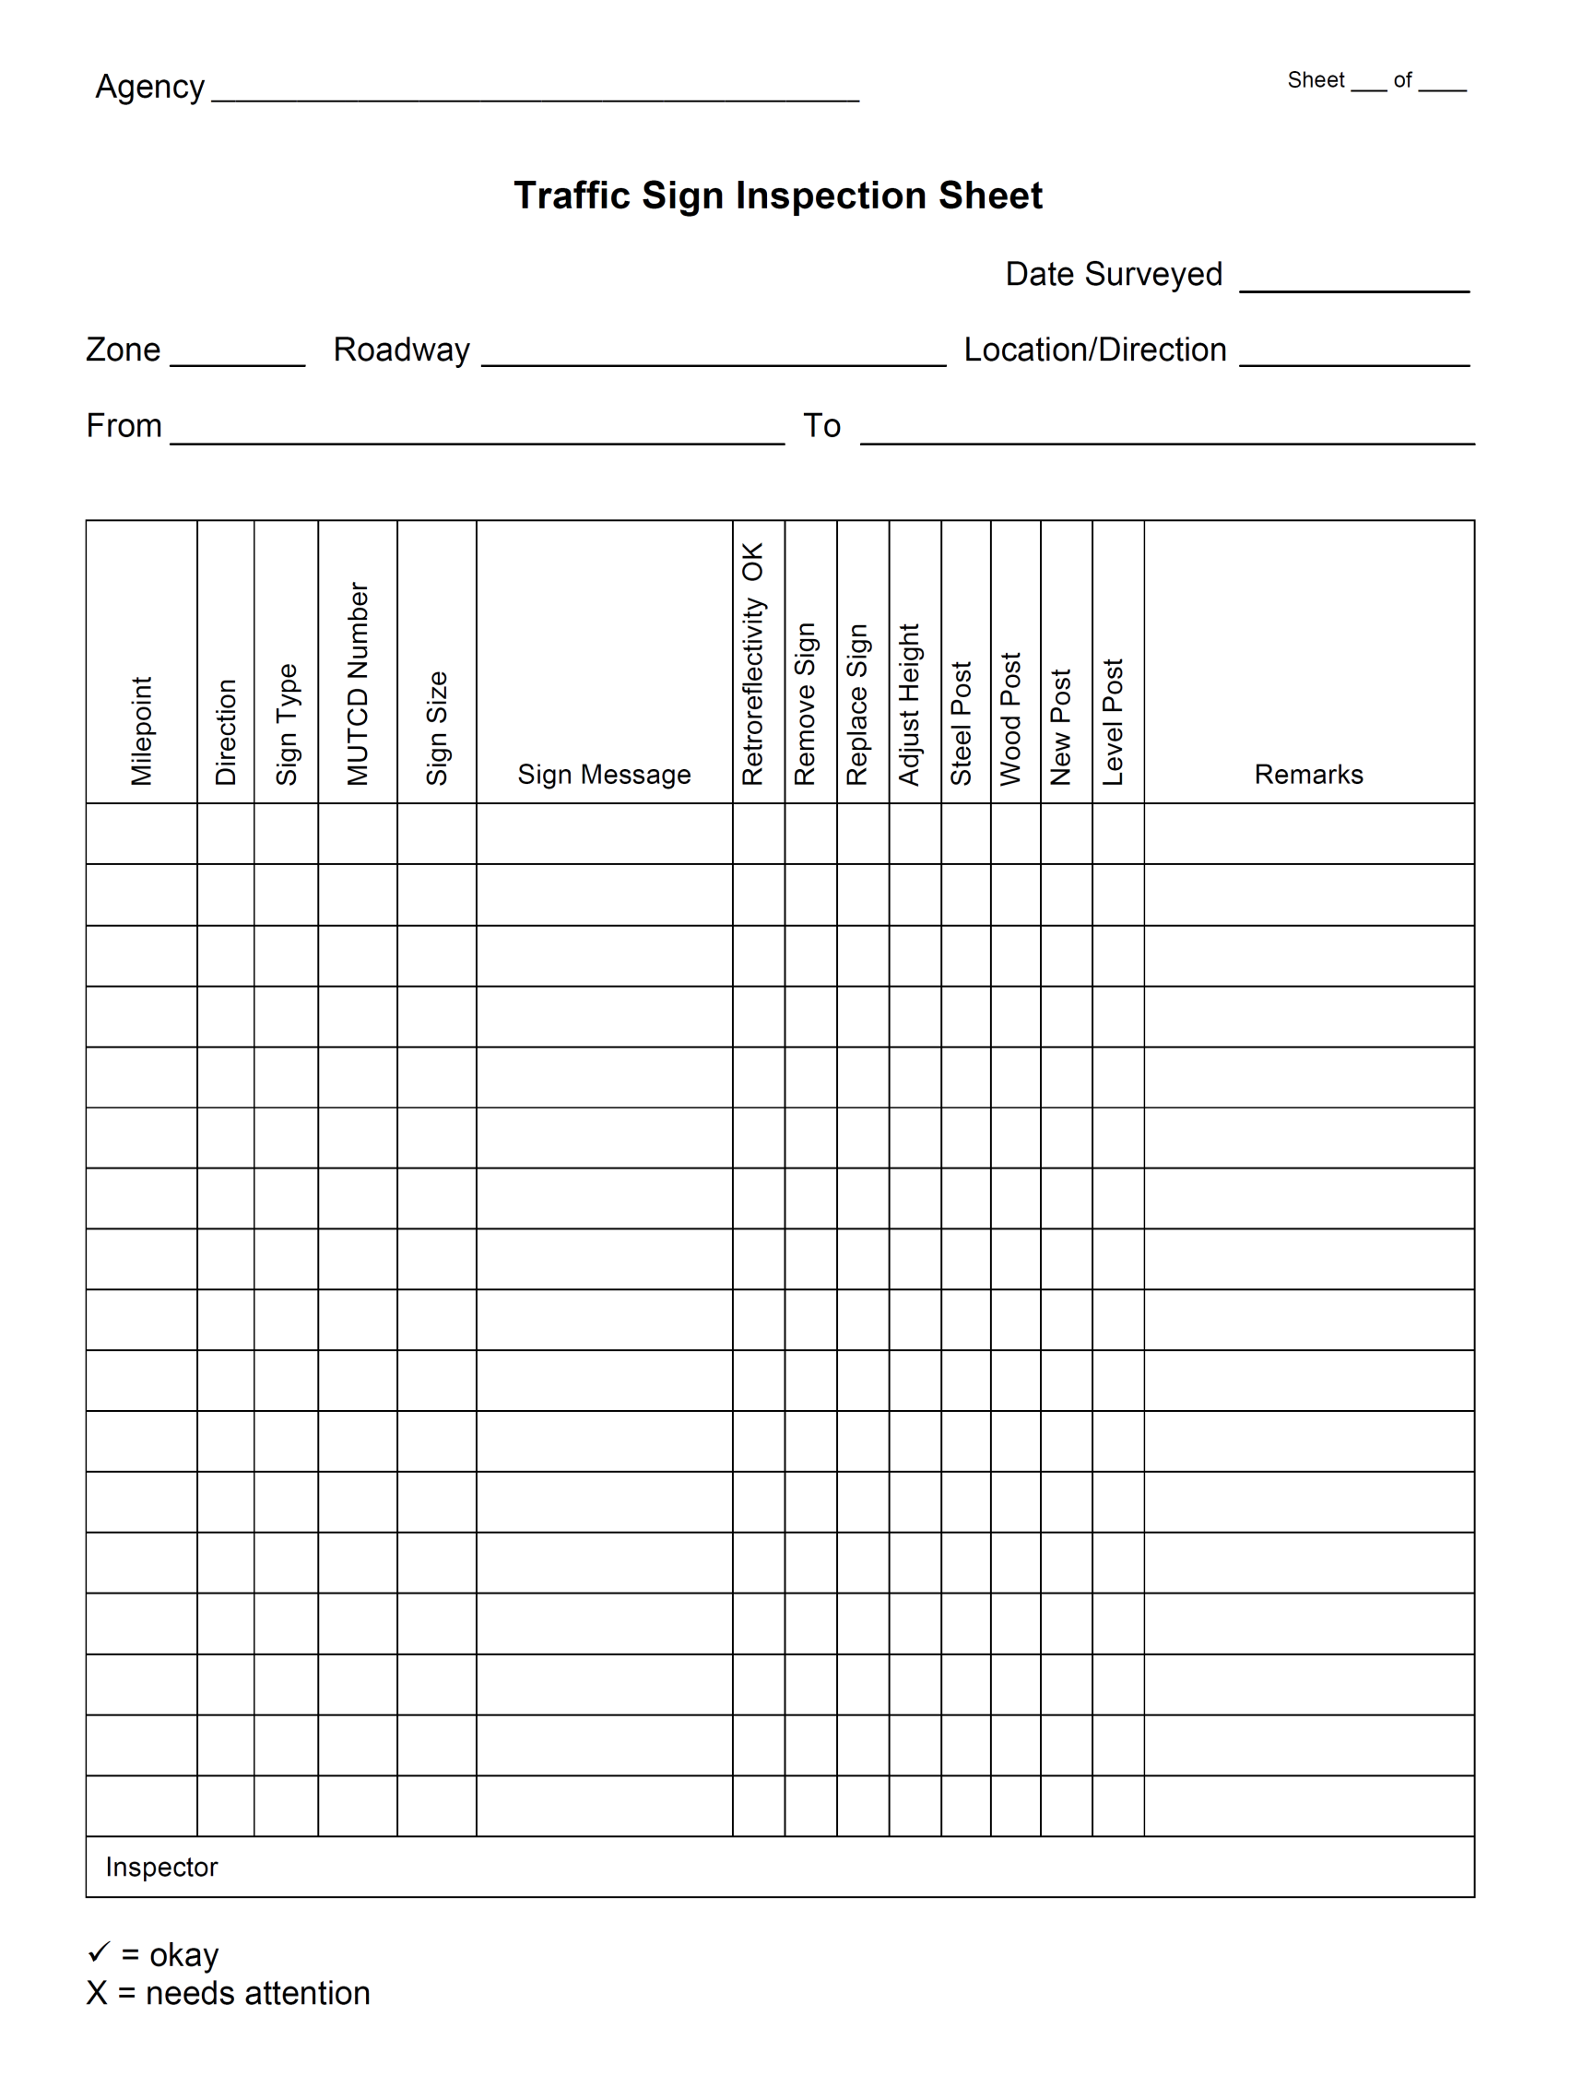
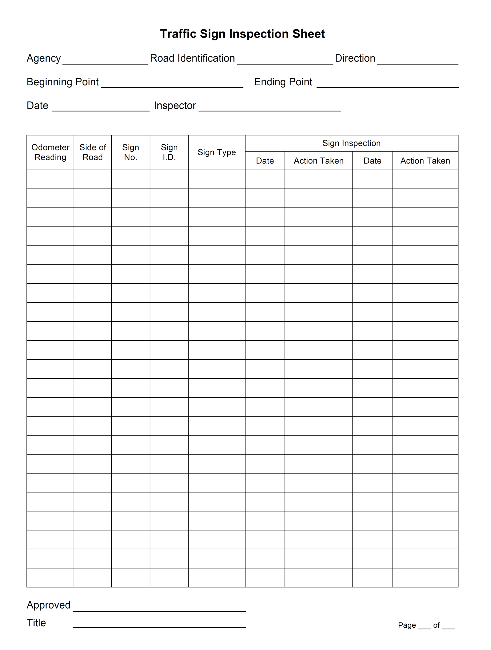

[ Blank Page ]

Page 10
Appendix B

Map of Township Zones for Traffic Sign Inspection

The Township has been divided into __________ Zones for conducting traffic sign inspections. The inventory process and inspection documentation will correspond to the roads and traffic signs the Township is responsible for within each Zone. The attached Township map shows the Zones and their boundaries.

Page 11

[ Attach Township Map(s) showing the Traffic Sign Inspection Zones ]

Page 12

Appendix C

Visual Nighttime Inspection Method –
Comparison Panels Procedure

Sign Retroreflectivity Inspection Form (example)

The Township will establish the documentation process to be used when conducting retroreflectivity inspections of traffic signs under its jurisdiction. Possible options include:
- The Traffic Sign Inspection Sheet or other form (see Appendix A) that is used for general condition inspections may also be used for retroreflectivity inspections, provided that the form is designed to accommodate data from both inspections.
- A separate Sign Retroreflectivity Inspection Form (see example attached) may be used. In order to use this type of form, it may be helpful to prepare the list of signs for each roadway in advance of the nighttime inspections. This list may be prepared from the traffic sign inventory.
- The Township may develop other forms or data collection processes for documenting the retroreflectivity inspections.

Page 13
Visual Nighttime Inspection Method –
Comparison Panels Procedure

The OMUTCD describes several assessment and management methods that may be used to maintain traffic sign retroreflectivity. The Federal Highway Administration has also published resource materials that describe procedures for using these methods.

For calendar year 2012, the Township has decided to use the Visual Nighttime Inspection Method – Comparison Panels Procedure to evaluate the retroreflectivity of traffic signs on its roads. The OMUTCD describes Visual Nighttime Inspection as follows:
“The retroreflectivity of an existing sign is assessed by a trained sign inspector conducting a visual inspection from a moving vehicle during nighttime conditions. Signs that are visually identified by the inspector to have retroreflectivity below the minimum levels should be replaced.”

Comparison Panels Procedure – Comparison panels are used to assess signs that have marginal retroreflectivity. The comparison panels are fabricated at retroreflectivity levels at or above the minimum levels. When the visual [nighttime] inspection identifies the retroreflectivity of a sign as marginal, a comparison panel is attached to the sign and the sign/panel combination is viewed and compared by the inspector. (“Maintaining Traffic Sign Retroreflectivity” – FHWA-SA-07-020)

The following FHWA resources include recommendations and instructions for proper use of the Comparison Panels Procedure to conduct nighttime visual inspections. Note: Comparison panels need to be properly stored, maintained, and checked with a retroreflectometer at periodic intervals to ensure that they have appropriate retroreflectivity levels.

- “Maintaining Traffic Sign Retroreflectivity” – FHWA-SA-07-020. (2007)
http://safety.fhwa.dot.gov/roadway_dept/night_visib/policy_guide/fhwasa07020/

- “Inspector Training for Sign Retroreflectivity” (PowerPoint presentation with instructor notes, October 2008) – FHWA ‘Sign Retroreflectivity Toolkit’ website / Educational Resources.
http://safety.fhwa.dot.gov/roadway_dept/night_visib/retrotoolkit/education/powerpoint.htm

- “Comparison Panels Procedure (with checklist)” – FHWA ‘Sign Retroreflectivity Toolkit’ website.
http://safety.fhwa.dot.gov/roadway_dept/night_visib/retrotoolkit/moreinfo/maint/assessment.htm

- “Methods for Maintaining Traffic Sign Retroreflectivity” – FHWA-HRT-08-026. (2007)
http://safety.fhwa.dot.gov/roadway_dept/night_visib/policy_guide/fhwahrt08026/

The Township will review these resources and adopt appropriate inspection practices for properly using the Comparison Panels Procedure to comply with the OMUTCD retroreflectivity standards. The procedure steps and requirements will be listed and attached to this document.

The Township will also determine the type(s) or extent of training their inspector(s) will need in order to perform this function in accordance with the OMUTCD requirements.

Page 14

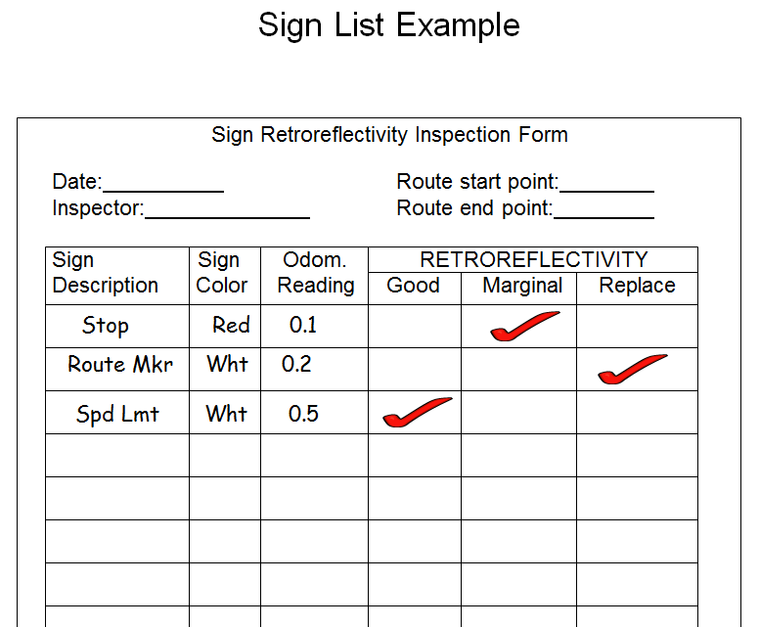

Shown above is one example of an inspection form that could be used for conducting visual nighttime inspections. Source: Federal Highway Administration – “Inspector Training for Sign Retroreflectivity” (PowerPoint presentation with instructor notes, October 2008). http://safety.fhwa.dot.gov/roadway_dept/night_visib/retrotoolkit/education/powerpoint.htm

Page 15

Page 16
‘Fill in the Blanks’ Version
Template 2 – Comparison Panels Procedure
Visual Nighttime Inspection Method
Traffic Sign Retroreflectivity Maintenance Program

It is recommended that agencies use the electronic version of this program template if at all possible. This allows each agency to adapt or modify the template to best suit their needs. The Microsoft Word file can be downloaded from the Ohio LTAP website, at:
http://www.dot.state.oh.us/Divisions/Planning/LocalPrograms/LTAP/Pages/ImplementingaTrafficSignRetroreflectivityMaintenanceProgram.aspx

Some agencies might not have computer access to the electronic version of this template. These agencies could consider working with their County Engineer’s Office, or another local agency in the area, in order to customize one of the electronic templates for their use.

Another possibility is to use a ‘fill in the blanks’ template. Attached are pages 1 through 6 of a ‘fill in the blanks’ version of the program template based on the Comparison Panels Procedure. Pages 7 through 16 (Appendices A, B and C) are available from the preceding ‘guide’ version of this template.

Please Note: It is recommended that you carefully review the program template with your County Engineer, insurance provider, or legal counsel prior to formally adopting your agency’s sign retroreflectivity maintenance program. Again, your agency is not required to use any of the templates developed by Ohio LTAP.

[ Blank Page ]

Traffic Sign Retroreflectivity Maintenance Program for ____________ Township (in ____________ County, Ohio) – Calendar Year ____

1. Introduction
“Retroreflectivity” refers to the property of a traffic sign to reflect light back to the driver. Retroreflective traffic signs are used to increase sign visibility at night. Maintaining sign retroreflectivity is important to promote nighttime traffic safety.

In January 2008, the Federal Highway Administration (FHWA) enacted new requirements for maintaining minimum levels of retroreflectivity for traffic signs. These requirements were established through the national Manual on Uniform Traffic Control Devices (MUTCD), and apply to all agencies that maintain roadways open to public travel. The MUTCD implementation resulted from a final rule published in the Federal Register on December 21, 2007.

The Ohio Manual of Uniform Traffic Control Devices (OMUTCD) is required to be in substantial conformance with the national MUTCD. The requirements for maintaining retroreflectivity of traffic signs in Ohio are set forth in Section 2A.08 of the OMUTCD.

The responsibility for the design, placement, operation, maintenance, and uniformity of traffic control devices rests with the public agency or the official having jurisdiction. Per Section 4511.11 of the Ohio Revised Code, local authorities shall place and maintain traffic control devices in accordance with the OMUTCD.

1.1 Implementation Requirements
The Federal Highway Administration published the following information on May 14, 2012. Source: Final Rule, Federal Register Vol. 77, No. 93.
Specific Provision: Implementation and continued use of an assessment or management method that is designed to maintain regulatory and warning sign retroreflectivity at or above the established minimum levels. Compliance Date: June 13, 2014.
Additional Comments:
Types of signs other than regulatory or warning are to be added to an agency’s management or assessment method as resources allow.
Even without specific FHWA compliance dates for replacement of signs, agencies will still need to replace any sign they identify as not meeting the established minimum retroreflectivity levels.

1.2 References
References and resources for this work include, but are not limited to:
Ohio Manual of Uniform Traffic Control Devices (OMUTCD) – current version –
http://www.dot.state.oh.us/omutcd
Section 2A.07 – Retroreflectivity and Illumination
Section 2A.08 – Maintaining Minimum Retroreflectivity
Section 2A.22 – Maintenance

Page 1
Additional parts/sections of the OMUTCD should be referred to as needed with regard to traffic sign management and maintenance functions.
Ohio Revised Code – Sections 4511.09 and 4511.11
Federal Highway Administration (FHWA) – Sign Retroreflectivity Resources
Nighttime Visibility Webpage – http://safety.fhwa.dot.gov/roadway_dept/night_visib/
Guide – http://safety.fhwa.dot.gov/roadway_dept/night_visib/sign_retro_4page.pdf

2. Policy Statement
____________________ Township will use the plan, method(s) and procedure(s) described herein to evaluate and maintain retroreflectivity of traffic signs under its jurisdiction, in accordance with the most current version of the Ohio Manual of Uniform Traffic Control Devices.

3. Implementation Plan
The anticipated steps in this plan for calendar year ________ are as follows.
- Create a traffic sign inventory for the Township (see section 4 of this document), and identify any sign problems/deficiencies that require corrective action.
- Use the selected method and procedure (see section 5) to evaluate the retroreflectivity of the Township’s traffic signs.
- Identify signs that do not meet the OMUTCD retroreflectivity requirements.
- Prioritize and schedule replacement of signs that do not meet the OMUTCD retroreflectivity requirements.

In light of the June 13, 2014 compliance date (see section 1.1), the Township hereby resolves to proceed with the implementation plan by ____________________ , or earlier if possible.

Based on experience gained as this program is implemented, the Township may review and modify its approach to this work as needed in order to:
- comply with the traffic sign retroreflectivity requirements per the OMUTCD; and
- provide for the safety of sign inspection/maintenance personnel, motorists, and other road users.
Any significant changes made to the plan, method(s) or procedure(s) will be documented.

4. Traffic Sign Inventory
Daytime inspections will be conducted to identify and document all traffic signs under the Township’s jurisdiction. At a minimum, the documentation from these inspections will include the sign type, location, and condition (see Appendix A). The inspections will also identify:
- Any damaged, deteriorated, or obscured signs, or other sign problems, that require immediate corrective action in the interest of traffic safety.
- Any signs or sign installations that do not meet the standards and requirements set forth in the OMUTCD.
The Township will take appropriate and reasonable steps to correct any sign problems/deficiencies identified.

Page 2
The data collected during the inspections will be used to create an inventory of the Township’s traffic signs. At the Township’s discretion, the sign inspection sheets may be organized in a notebook or filing system; or, data from the inspection sheets may be transferred to a separate spreadsheet or computer database. The Township will evaluate the available options and methods for long-term maintenance and updating of its sign inventory.

The Township has been divided into __________ Zones for conducting traffic sign inspections (see Appendix B). The inventory process and inspection documentation will correspond to the roads and traffic signs the Township is responsible for within each Zone. The sign inventory should be completed for Zone 1 by __________________ , and for Zone 2 by __________________.

5. Method for Maintaining Traffic Sign Retroreflectivity
The OMUTCD describes several assessment and management methods that may be used to maintain traffic sign retroreflectivity. For calendar year ________, the Township will use the Visual Nighttime Inspection Method – Comparison Panels Procedure to evaluate the retroreflectivity of traffic signs on its roads. The OMUTCD describes Visual Nighttime Inspection as follows:
“The retroreflectivity of an existing sign is assessed by a trained sign inspector conducting a visual inspection from a moving vehicle during nighttime conditions. Signs that are visually identified by the inspector to have retroreflectivity below the minimum levels should be replaced.”

Comparison Panels Procedure – Comparison panels are used to assess signs that have marginal retroreflectivity. The comparison panels are fabricated at retroreflectivity levels at or above the minimum levels. When the visual [nighttime] inspection identifies the retroreflectivity of a sign as marginal, a comparison panel is attached to the sign and the sign/panel combination is viewed and compared by the inspector. (“Maintaining Traffic Sign Retroreflectivity” – FHWA-SA-07-020)

5.1 Procedure
The Federal Highway Administration has published several resources that include recommendations and instructions for proper use of the Comparison Panels Procedure to conduct visual nighttime inspections (see Appendix C). The Township will review these resources and adopt appropriate inspection practices for properly using the Comparison Panels Procedure to comply with the OMUTCD retroreflectivity standards. The procedure steps and requirements will be listed and attached to this document.

5.2 Inspector(s)
The Township hereby designates the following person(s) to serve as retroreflectivity inspector(s):

________________________________ ________________________________

The Township has determined that the designated person(s) are able to competently serve as inspector(s) for evaluating traffic sign retroreflectivity. The Township will review applicable FHWA guidelines and resources with regard to inspector training, and will determine the type(s) or extent of training their inspector(s) will need in order to perform this function in accordance with the OMUTCD requirements.

Page 3
5.3 Schedule and Documentation
The Township will begin its use of the Visual Nighttime Inspection Method – Comparison Panels Procedure to evaluate traffic sign retroreflectivity no later than __________________. The traffic sign retroreflectivity inspections should be completed for Zone 1 by __________________ , and for Zone 2 by __________________ .

The retroreflectivity inspection records will be kept in a notebook or filing system that will be accessible to the Township Trustees. Documentation from each inspection process will be kept for a period of at least __________ years.

Looking ahead, the Township plans to conduct sign retroreflectivity assessments with a frequency of ________________________. Future renewals or revisions of this program document will describe the timeframe or frequency for conducting retroreflectivity assessments.

6. Additional Responsibilities for Traffic Sign Management and Maintenance
Retroreflectivity is just one of several factors associated with proper functioning of traffic signs. The Township continues to be responsible for the overall management and regular maintenance of signs under its jurisdiction, in the interest of traffic safety.

The following text is included in OMUTCD Section 2A.22 – Maintenance:
“Maintenance activities should consider proper position, cleanliness, legibility, and daytime and
nighttime visibility (see Section 2A.08). Damaged or deteriorated signs should be replaced.

To assure adequate maintenance, a schedule for inspecting (both day and night), cleaning, and replacing signs should be established. Employees of highway, law enforcement, and other public agencies whose duties require that they travel on the roadways should be encouraged to report any damaged, deteriorated, or obscured signs at the first opportunity.

Steps should be taken to see that weeds, trees, shrubbery, and construction, maintenance, and utility materials and equipment do not obscure the face of any sign.”

Responsibility and authority for directing the Township’s various sign management and maintenance functions, including the retroreflectivity maintenance program, is hereby assigned to:
________________________________.

7. Documentation and Recordkeeping
The Township will establish a recordkeeping system to organize the documentation relating to its traffic sign management and maintenance functions, including:
- Creating and maintaining the sign inventory.
- Conducting routine, periodic condition inspections of signs.
- Conducting retroreflectivity inspections of signs.
- Maintenance-related activities / corrective actions / emergency measures, including those done in response to notification or discovery of knocked down, missing, damaged, deteriorated, or obscured signs.

Page 4
Documentation from each inspection cycle and maintenance-related activity will be kept on file for a period of at least __________ years.

8. Annual Program Review and Renewal
Traffic sign retroreflectivity degrades over time. Therefore, maintaining retroreflectivity is an ongoing responsibility. The Township will review and renew this program document at least once per year. The usual process will be to conduct the review by ____________________ for the next calendar year. Any needed changes will be made to the document, and the updated version for the next year will be adopted under the authority of the Township Trustees no later than ____________________.

This process will take into account the ongoing need to replace any sign identified as not meeting the established minimum retroreflectivity levels.

The Township is responsible for identifying any applicable future updates or revisions to the Ohio MUTCD standards or Federal regulations relating to traffic control devices, and updating this program document (including appendices/attachments) as needed to assure compliance.

Over time, the Township may consider using other sign retroreflectivity assessment or management methods. Future renewals or revisions of this program document will describe the method(s), procedure(s), and the timeframe or frequency with which they will be used. The Township may also consider expanding this program document to more fully describe its other traffic sign maintenance and management functions (see sections 6 and 7).

The Township may consult with the ________________________ County Engineer's Office for general guidance and further information regarding traffic sign maintenance and management issues.

9. Authorizing Signatures
The provisions set forth in this program document are hereby adopted this ________ day of ____________________ , ________ , for implementation by ________________________ Township, under the authority of the Township Trustees:

___________________________________________________________________________________
Name Signature Date

___________________________________________________________________________________
Name Signature Date

___________________________________________________________________________________
Name Signature Date

Page 5

[ Blank Page ]

Page 6
Attach Appendices if Using the ‘Fill in the Blanks’ Version
Template 2 – Comparison Panels Procedure

Please note:
Pages 7 through 16 (Appendices A, B and C) are available from the preceding ‘guide’ version of this template.

